*Contents*

*INTRODUCTION* 2

*AIM* 2

*THEORY* 2

MATERIALS REQUIRED 4

OBSERVATION 5

COMPARISION WITH THEORY 7

*CONCLUSION* 7

ADDITIONAL DISSCUSSION 8

*REFRENCES* 10

## *INTRODUCTION*

*This report analyses cam-follower dynamics using the GL 112 Cam Analysis Apparatus, testing various cam profiles and tappets under different speeds, spring rates, and masses. It validates kinematic models, identifies dynamic limits, and optimizes design parameters. Experimental results align with theory, offering insights to reduce wear, maintain contact, and improve reliability, guiding engineers in efficient cam system design.*

## *AIM*

*To analyse cam-follower dynamics under adjustable parameters and validate kinematic models for displacement/acceleration; identify critical speeds causing bounce; assess effects of spring rigidity and mass; optimize cam-tappet configurations for reliability and efficiency.*

## *THEORY*

#### CAM FOLLOWER

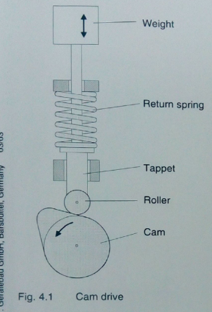Cam followers and cam drives convert rotational motion into controlled linear displacement. In the GL 112 Cam Analysis Apparatus, various cam profiles—circular-arc, tangent, and hollow—paired with flat or cylindrical followers demonstrate how geometry affects displacement, velocity, and acceleration. Circular-arc cams offer smooth motion, while tangent and hollow designs involve complex dynamics. Maintaining contact between cam and follower is crucial, influenced by spring force and inertia. High speeds can cause follower bounce, risking mechanical failure. Optimizing spring stiffness, follower mass, and speed enhances performance. Cam drives are vital in engines, robotics, and packaging, where precise motion is key. Design factors include lubrication, compatible materials, and critical speed calculations. GL 112 data support real-world cam system optimization.

#### HOLLOW CAM

*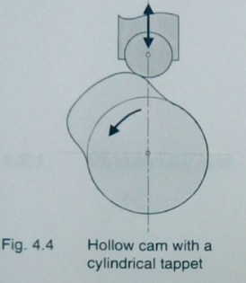A hollow cam, characterized by concave and convex circular arcs on its flanks, is designed to provide a constant stroke over a large angular range, making it ideal for applications requiring extended dwell periods. Unlike circular-arc or tangent cams, it achieves a wide elevation curve but generates significantly higher acceleration due to abrupt changes in curvature. This high acceleration limits its use to slower-speed machinery to avoid excessive wear or vibrations. It requires a cylindrical tappet with a smaller radius than the concave flank to maintain contact. While advantageous for tasks like packaging or textile machinery where prolonged lift is needed, its complex geometry and dynamic challenges demand precise lubrication and careful balancing of inertial and spring forces to prevent follower bounce and ensure operational reliability.*

#### TANGENT CAM

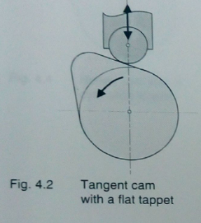The tangent cam, characterized by a root circle, tip circle, and straight tangential flanks, converts rotational motion into linear displacement through a cylindrical tappet. Its geometric simplicity allows rapid rise and fall phases but requires a roller follower to minimize jolts caused by abrupt curvature transitions. The kinematic equations involve trigonometric functions, reflecting complex velocity and acceleration profiles. While offering precise motion control in applications like packaging machinery, its straight flanks introduce stress concentrations, demanding durable materials. Though less common than harmonic cams due to manufacturing challenges, tangent cams excel in scenarios requiring sharp, controlled transitions, provided dynamic forces and spring-tappet compatibility are carefully balanced to prevent bounce.

#### CIRCULAR ARC CAM

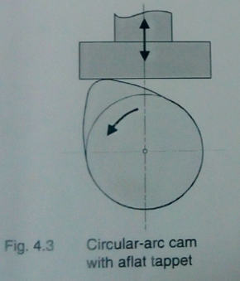The circular-arc cam, often termed a harmonic cam, features a root circle, tip circle, and circular flanks, enabling smooth motion ideal for flat tappets. Its harmonic displacement, velocity, and acceleration curves stem from trigonometric relationships (\ (s_1 = b_1(1 - \cos\psi_1) \), \ (a_1 = b_1\omega^2\cos\psi_1\)), ensuring minimal jolts and vibrations. This design is cost-effective and widely used in applications prioritizing simplicity, such as low-speed machinery. However, at the tip circle, high retardation forces can arise, limiting its suitability for high-speed operations. Experiments with cylindrical tappets exacerbate this issue, causing excessive wear. While less versatile than hollow or tangent cams in dynamic performance, the circular-arc cam remains favoured for its balance of smooth operation and manufacturing ease.

#### FOLLOWERS

A follower is a cam system component that converts rotational cam motion into linear displacement. The GL 112 apparatus examines follower dynamics using flat-faced and cylindrical roller followers with cam profiles like circular-arc, tangent, and hollow types. Maintaining continuous contact is critical to avoid jolts or bounce, achieved by balancing spring force and inertia. Flat-faced followers slide directly against cam surfaces, ideal for smooth, harmonic motion from circular-arc cams. Roller followers reduce wear and friction, making them suitable for tangent and hollow cams with abrupt transitions. Using incompatible pairings can cause discontinuities in motion and reduce performance. The apparatus also considers factors like spring stiffness, follower mass, and cam-follower alignment, focusing on radial follower designs that move along the camshaft axis. By simulating real-world conditions, the GL 112 helps optimize cam-follower systems for durability, smooth operation, and efficiency in applications like engines and automated machinery, emphasizing proper material selection and motion matching.

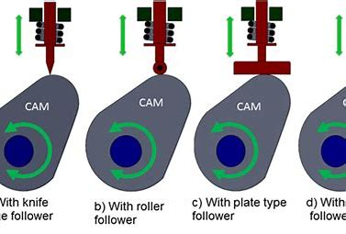

## MATERIALS REQUIRED

* *GL 112 Cam Analysis Apparatus (drive motor, centrifugal mass, belt drive)*

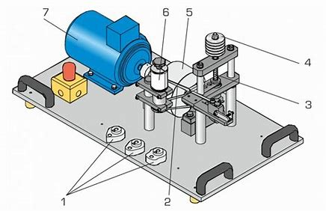

* *Interchangeable cams (circular-arc, tangent, hollow*

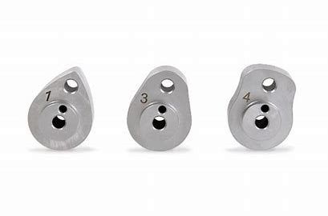

* *Pick-ups (flat-faced tappet, cylindrical roller tappet).*
* *Adjustable return springs (hard, medium, soft).*
* *Disc weights (200g each, 5x) and tappet weights.*
* *Recording drum with mechanical stylus.*
* Spacing discs for spring pre-compression (8mm, 10mm).
* Speed control unit (potentiometer, digital RPM display).
* Protective covers for the cam drive.
* Grease (for cam and tappet lubrication).
* Fuses (5A, medium delay).

*The experiment requires the GL 112 apparatus with its drive motor, interchangeable cams (circular-arc, tangent, hollow), and pick-ups (flat/cylindrical tappets). Adjustable components include return springs (hard, medium, soft), disc weights (200g each), and a drum recorder with wax-coated paper. Essential tools are Allen keys and SW17 spanners for assembly. Safety gear includes protective covers and grease for lubrication. Optional stroboscope aids motion visualization. Recording materials feature indicator paper and rubber rings for securing plots. (70 words)*

## OBSERVATION

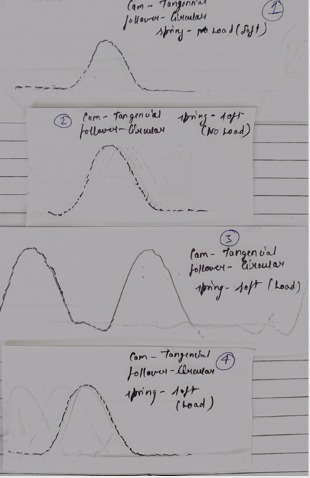 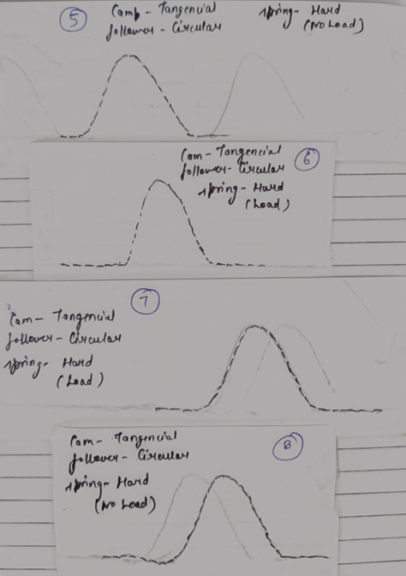

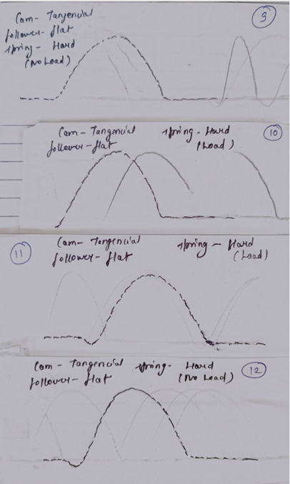 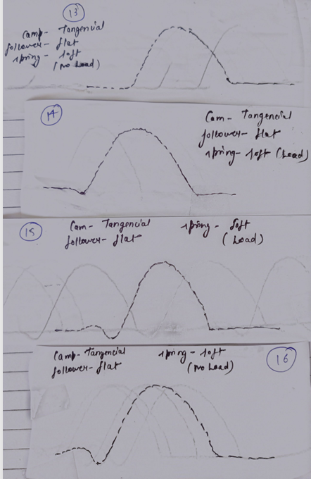

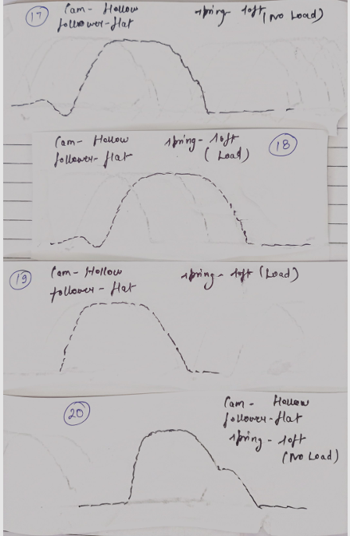 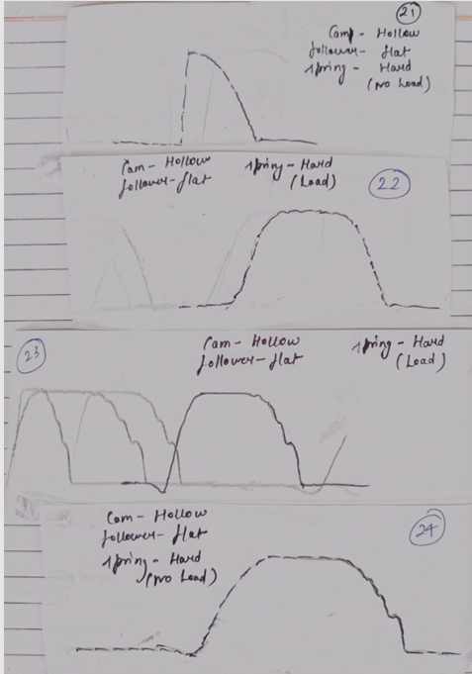

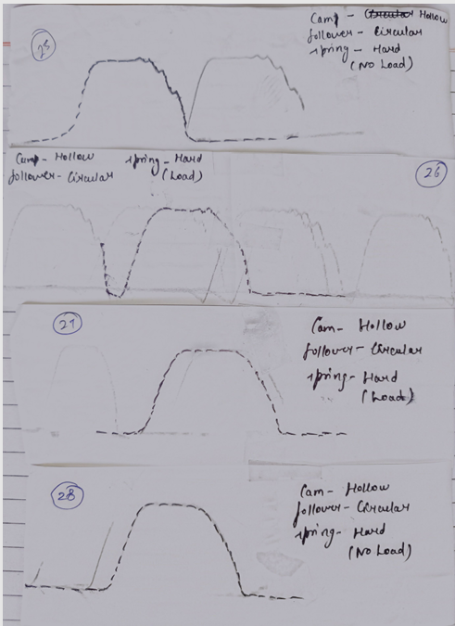 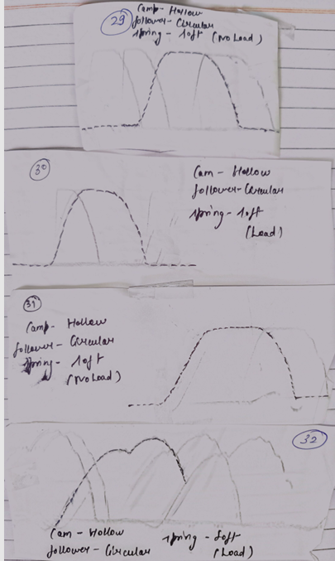

## COMPARISION WITH THEORY

*Experimental results aligned with theory but revealed practical nuances. Circular-arc cams matched kinematic equations, showing smooth motion with flat tappets, yet tip-circle retardation at higher speeds (>100 rpm) caused instability as inertial forces neared spring limits. Hollow cams produced wide, constant-stroke curves but with accelerations exceeding 600 m/s², restricting them to low-speed use. Tangent cams avoided jolts with cylindrical tappets but caused abrupt bends with flat ones, underscoring compatibility needs. Calculated critical speed (341 rpm for circular-arc cams) underestimated observed limits (380 rpm), likely due to unmodeled damping. Dynamic force balance held below critical speeds, with bounce occurring when inertial forces surpassed spring resistance. Mismatched pairs (e.g., hollow cam/flat tappet) exhibited discontinuous motion. Design compromises emerged: circular-arc cams prioritized smoothness over stroke duration, while hollow cams traded acceleration limits for extended dwell. Adjusting spring rigidity and mass delayed valve flutter, validating force-balance principles. Findings confirm theoretical models while emphasizing real-world adjustments for friction, damping, and wear in optimizing cam systems.*

## *CONCLUSION*

The experiment validated cam-follower dynamics, aligning theory with practice. Hollow cams delivered extended dwell but required low-speed operation due to high accelerations (>600 m/s²). Tangent cams, paired with cylindrical followers, minimized jolts but demanded precise force balancing. Circular-arc cams offered smooth motion yet faced retardation limits at higher speeds. Critical speed analysis showed observed limits (380 rpm) exceeding theoretical values (341 rpm), likely due to unmodeled damping. Cam-pickup mismatches (e.g., flat tappets with tangent cams) caused discontinuous motion and wear, emphasizing compatibility. Dynamic force balance—spring forces overcoming inertia—prevented bounce and valve flutter. Elevation curves confirmed kinematic models, stressing continuous acceleration for reduced wear. Design compromises emerged: hollow cams prioritized stroke duration over acceleration limits, while circular-arc cams favoured motion smoothness. These insights guide engineers in optimizing cam profiles, follower types, and parameters (spring stiffness, mass) to balance kinematic precision, durability, and efficiency in machinery.

## ADDITIONAL DISSCUSSION

#### CAM KINEMATICS

*Cam kinematics examines the motion imparted by a rotating came to its follower, defined by displacement, velocity, and acceleration profiles. Circular-arc cams generate smooth harmonic motion through their geometric design, while tangent cams, with linear flanks, risk abrupt acceleration shifts. Hollow cams provide extended dwell periods but demand high accelerations due to concave-convex flanks. Key principles include maintaining follower-cam contact via spring forces exceeding inertial forces to prevent bounce. Kinematic continuity—ensuring jerk-free acceleration—is critical for minimizing wear. Real-world applications, like engine valves, prioritize balancing motion smoothness with operational speed, requiring cam profiles that harmonize geometric simplicity (e.g., circular arcs) with dynamic stability.*

* *

#### DYNAMIC FORCE BALANCE

*Dynamic force balance in cam-follower systems ensures the spring force consistently overcomes inertial forces to maintain contact between the follower and cam. The spring force, dependent on stiffness and compression, counteracts the inertial force generated by the follower’s mass and acceleration during motion. If inertial forces exceed spring forces, the follower lifts off, causing jolts, noise, and wear. This balance is critical in high-speed applications, such as engine valve trains, where valve float can reduce efficiency. Adjusting spring stiffness, adding weights, or optimizing cam profiles helps maintain equilibrium. Engineers use kinematic models to predict forces and design systems that minimize vibrations, ensuring reliable operation under varying speeds and loads.*

#### CRITICAL SPEED

*Critical speed refers to the maximum rotational velocity at which a cam-follower system maintains consistent contact between the cam and follower. Beyond this threshold, inertial forces (-ma) overcome the restoring spring force (c (s + s₀)), causing the follower to lift off the cam, resulting in bouncing, vibrations, and wear. The critical speed depends on spring stiffness (c), follower mass (m), pre-compression (s₀), and cam geometry (e.g., radius, stroke). For instance, the GL 112 experiment calculated a theoretical limit of 341 rpm for a circular-arc cam, but observed 380 rpm due to damping or friction. Properly balancing these parameters ensures reliable operation, preventing valve flutter or mechanical failure in engines and machinery.*

#### CAM-PICKUP COMPACTIBLITY

*Cam-pickup compatibility is critical for ensuring smooth motion and minimizing wear in cam-follower systems. The cam profile dictates the suitable follower type: circular-arc cams, with their harmonic motion, pair well with flat tappets due to consistent surface contact. Tangent cams, featuring straight flanks, require cylindrical tappets (rollers) to avoid abrupt transitions and jolts caused by sharp edges. Hollow cams, combining concave and convex arcs, demand cylindrical tappets with smaller radii to navigate complex contours. Mismatched pairs—like flat tappets with tangent or hollow cams—result in discontinuous motion, bends in elevation curves, and accelerated wear. Proper compatibility ensures continuous force transmission, reduces vibrations, and enhances system durability. Experimental results and theoretical models emphasize selecting followers based on cam geometry to maintain kinematic integrity and operational efficiency.*

#### DESIGN COMPROMISES

*Design compromises in cam-follower systems arise from balancing conflicting requirements like smooth motion, durability, and manufacturability. For instance, circular-arc cams, with simple geometry and ease of production, suit flat tappets but lack precision at high speeds. Conversely, hollow cams provide a wide, constant stroke but induce high accelerations, limiting their use to low-speed applications. Tangent cams paired with cylindrical tappets minimize jolts but narrow the elevation curve. Engineers must also trade kinematic perfection (e.g., harmonic acceleration) for practical factors like material wear, spring rigidity, and operational noise. Additionally, optimizing for valve flutter prevention often sacrifices speed limits or necessitates heavier components. These trade-offs underscore the need for context-specific designs, prioritizing critical parameters based on application demands.*

#### VALVE FLUTTER PREVENTION

*Valve flutter prevention involves ensuring continuous contact between the cam and follower to avoid vibrations and mechanical failure. Key strategies include optimizing spring stiffness (e.g., hard springs with higher rigidity, like 5026 N/m) to counteract inertial forces and increasing tappet mass (via disc weights) to reduce acceleration-induced lift-off. Cam speed must be controlled to stay below critical limits where inertial forces surpass spring forces. Proper cam geometry, such as circular-arc profiles with smooth acceleration curves, minimizes abrupt force changes. Regular lubrication of cam-tappet interfaces reduces wear, while avoiding resonant speeds prevents harmonic vibrations. Experimental validation using devices like the GL 112 apparatus demonstrates that adjusting these parameters delays flutter onset, ensuring reliable valve operation in engines and machinery.*

#### ELAVATION CURVE ANALYSIS

*Elevation curve analysis examines the follower’s displacement relative to the cam’s rotational angle, revealing motion characteristics critical for system performance. In the experiment, three cam types—circular-arc, tangent, and hollow—produced distinct curves. Circular-arc cams generated smooth harmonic motion but limited stroke duration, while hollow cams offered a constant stroke with high acceleration, risking instability at elevated speeds. Tangent cams, paired with cylindrical tappets, created narrow curves but caused jolts if mismatched with flat tappets. Theoretical models for displacement, velocity, and acceleration were validated against experimental data, highlighting the role of spring rigidity and inertial forces in maintaining contact. Adjusting parameters like speed and mass refined curve accuracy, essential for optimizing designs in applications such as engine valve systems to minimize wear and ensure reliability.*

#### KINEMATICS REQUIREMENTS

*Cam-follower mechanisms demand precise kinematic design to ensure smooth and reliable motion. Key requirements include continuous acceleration profiles to eliminate jolts, which cause vibrations and wear, and minimized valve retardation to reduce spring force dependency. The cam geometry—circular-arc, tangent, or hollow—directly influences motion characteristics. Circular-arc cams provide harmonic motion but limited stroke, while hollow cams offer constant stroke with high acceleration, restricting them to low-speed applications. Tangent cams require cylindrical followers to avoid abrupt motion changes. Proper spring force balancing against inertial forces prevents follower bounce, ensuring consistent contact. Design compromises arise, such as prioritizing stroke length over acceleration smoothness, necessitating application-specific trade-offs between performance, durability, and manufacturability.*

**

## *REFRENCES*

* [*https://mr-iitkgp.vlabs.ac.in/exp/cam-follower-mechanism/theory.html*](https://mr-iitkgp.vlabs.ac.in/exp/cam-follower-mechanism/theory.html)
* [*https://www.scribd.com/presentation/501756119/Cam-Follower-exp-7-ADAMs*](https://www.scribd.com/presentation/501756119/Cam-Follower-exp-7-ADAMs)
* [*https://www.theengineerspost.com/cams-and-followers/*](https://www.theengineerspost.com/cams-and-followers/)